**FIN 334 – Fund Analysis: Delafield Fund**

**Question 1**

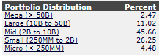

As the name does not specify any specific market cap restraints, this distribution seems fine. The fund is mostly invested in mid and small cap stocks. The fund is officially characterized as a mid-cap, making the small investments in micro and mega-cap appropriate. The almost 46% distribution into mid-cap stocks also reinforces this classification. Overall, none of the investments (apart from mega and micro-cap) seem out of line with the description of the fund. Interestingly, the fund itself does not define a market capitalization breakdown for the Delafield fund, whereas the Tocqueville fund, which is the other fund managed by Delafield’s two managers, has the same market cap breakdown as we used in this class.

**Question 2**

Fund Co-Managers: John Dennis Delafield, Jr. and Vincent Sellecchia who manage a total position of $570M in AUM at the Delafield fund. The following funds are also managed by either of the two names mentioned above:

1. The Tocqueville Select Fund ($62.2M), which is managed by both as well as Donald Wang

Both funds managed by Delafield and Sellecchia are value fund, with the Tocqueville fund classified as multi-cap and the Delafield fund as mid-cap. Generally, it is good to see both managers only manage one other fund. This ensures that they have enough resources and time available to actually actively manage both and do not dilute their interest in one of them, On the flip side, experience with a total of “only” $630M AUM, both managers might lack some experience in managing larger sums of money. Additionally, it might be questioned as to why they are only managing two funds: did they have to opportunity to manage more, but decided to focus on those two, or did they never get the opportunity to manage more due to poor performance.

**Question 3**

Basic Ratios:

|  |  |
| --- | --- |
| Avg P/E Ratio | 18.64 |
| Avg P/B Ratio | 2.39 |
| Avg Div Yld (%) | 1.27 |
| Avg Sales Growth (%) | 0.43 |
| Price Momentum | 1.08 |
| Relative Strength | 13.00 |
| Beta | 1.11 |

The fund appears to have a moderately high P/E ratio, which may be expected considering its 17.81% stake in electronic technology, but which seems somewhat too high for an alleged value fund. Additionally, it shows a very low P/B ratio and a decent dividend yield (good for a value fund), but a very low average sales growth, which can be expected from its significant value investments in more stable, blue chip industries, like industrial services or producer manufacturing.

**Question 4**

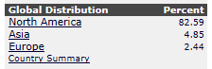

The fund is mostly invested in the North American market, with only a small stake in Europe and the emerging market of Asia (which could explain at least some of the contribution to its high relative strength score). Interestingly, factset shows the geographic breakdown of only about 90% of the fund’s investment, whereas Morningstar classified 89.5% of the fund’s holdings in North America, about 5% in non-US stocks and another 5.5% in cash. Hence, it is somewhat unclear where the remaining 10% of the fund are invested in.

**Question 5**

Morningstar rating: 2 stars

**Question 6**

Best Benchmark: iShares S&P Midcap 400 Value

*Note:* The fund has a bigger than 10% stake in non-equity products (mainly short-term treasuries) as well as a 10% stake in cash, which can dilute the following risk assessment and benchmark selection, as the benchmark is 99.5% invested in US equities only. Additionally, Barra leaves out non-equity investments for its analysis. Additionally, the fund itself is very ambiguous about defining its own benchmark in its prospectus, making it hard to find an accurate index to compare the fund to.

|  |  |
| --- | --- |
| **Benchmark** | **Active Risk** |
| Smallcap 600 | 7.39 |
| Russell 1000 | 9.77 |
| Russell 2000 | 7.40 |
| Midcap 400 | 7.43 |
| Largecap 500 | 10.24 |
| S&P 1500 | 9.44 |
| iShares S&P Midcap 400 Value | 6.29 |

**Question 7**



1-yr benchmark return (price): -3.16%

3-yr benchmark return (price): 9.40%

5-yr benchmark return (price): 9.33%

**Question 8**

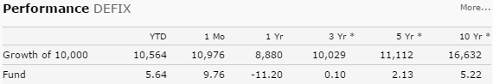

1-yr fund return: -11.2%

3-yr fund return: 0.1%

5-yr fund return: 2.1%

**Question 9**

Active risk: 16.89%

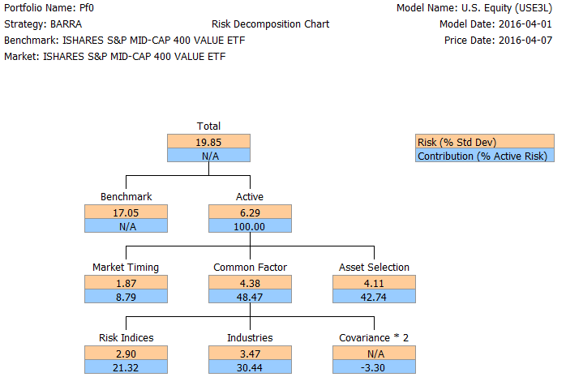

**Question 10**

According to the chart given in class, an active risk of 6.29% would classify it as a growth fund. This is interesting, because the fund advertises itself as a value fund, and its low average sales growth would also indicate that it isn’t necessarily a growth fund. From this perspective it appears that the fund is taking on too much risk (as the typical range for value funds ranges from 3%-6%). However, as already mentioned above, the fund’s large investments in fixed income products might distort the active risk relative to a benchmark that is almost entirely invested in US equities.

**Question 11**

The common factor risk is 4.38%, which contributes 48.47% to the total active risk of the fund, which could be due to the fund’s heavy sector bets in industrials, materials and financials. Risk indices make a total contribution of 21.32% (or 2.90% risk) to the active risk, whereas exposure to industry-specific risk contributes 30.44% (or 3.47% in risk) to the fund’s total active risk. A thing to note is the relatively high contribution of Asset Selection to the overall risk, with about 43%, indicating that both managers may not have the best stock-picking skills as almost half of their idiosyncratic risk is due to their investment choices.

**Question 12**

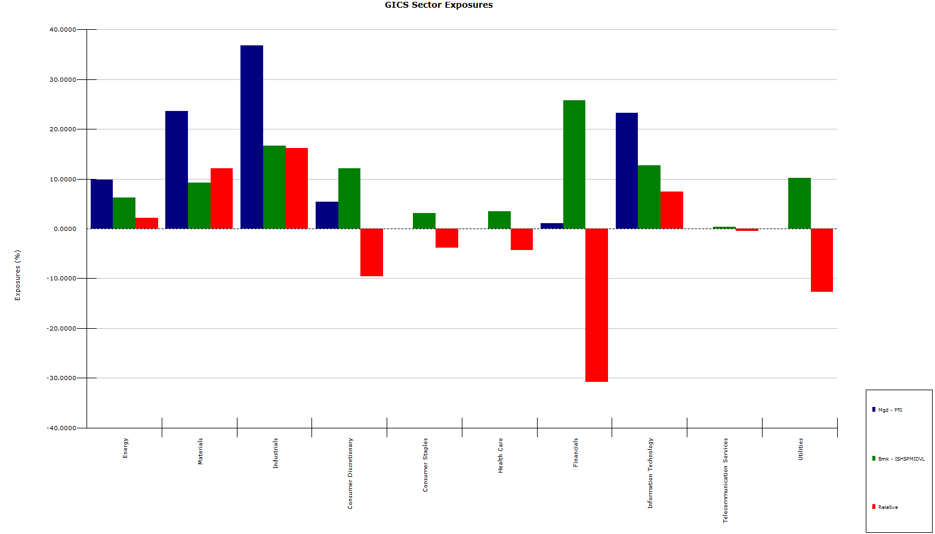

As can be seen from the above chart, the Delafield Fund shows significant differences in sector exposures to the benchmark ETF. The Fund has a significant under-exposure in financials, utilities and consumer discretionary, and a significant over-exposure in materials industrials and IT. This might explain the low sales growth of the fund as well as the high relative strength.

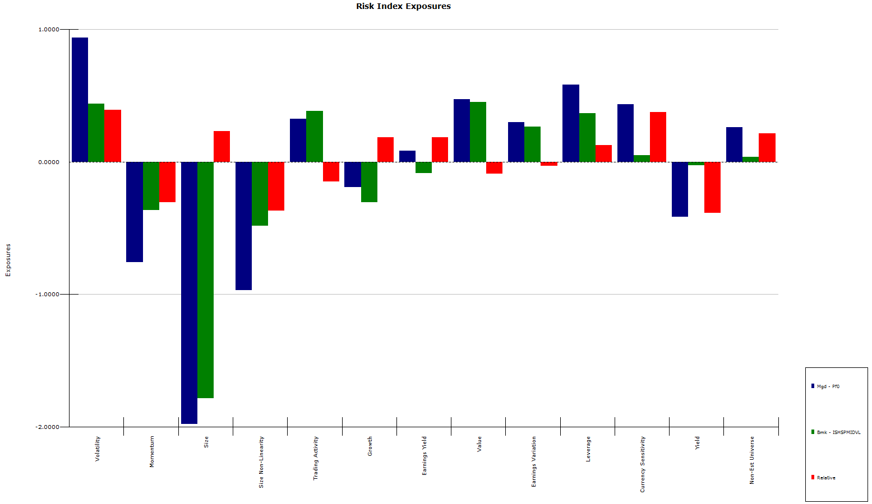**Question 13**

In terms of index exposure, the Delafield fund is overweighed in volatility and currency sensitivity (which can be due to its exposure to both European and Chinese equities) and non-est. universe. The fund tends to have a larger exposure to smaller sized companies relative to the mid-cap ETF, and also seems to over-invest in lower-momentum stocks (which might explain the fund’s low price momentum) and lower yield stocks (which is reflected in the fund’s low dividend yield). Overall none of the risk index exposures seem too surprising, apart from maybe the magnitude, which again might be diluted from the fund’s 10% stake in fixed income instruments.

**Question 14**

Stocks that provide the most risk, excluding cash (least diversified):

1. Consol Energy Inc. (CNX)
2. Ryerson Hldg. Corp. (RYI)
3. Kemet Corp. (KEM)
4. Harsco Corp. (HSC)
5. Xerium Technologies In. (XRM)

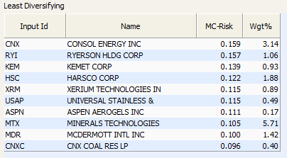

**Question 15**

Stocks that add the most style risk, excluding cash (least diversified):

1. Ryerson Hldg. Corp. (RYI)
2. Kemet Corp. (KEM)
3. Xerium Technologies In. (XRM)
4. Universal Stainless & Co. (USAP)
5. Harsco Corp. (HSC)

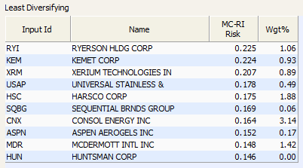

**Question 16**

Stocks that add the most sector/industry risk, excluding cash (least diversified):

1. Franks Intl. N V (FI)
2. Aspen Aerogels Inc. (ASPN)
3. Boardwalk Pipeline Par. (BWP)
4. Consol Energy Inc. (CNX)
5. Fairchild Semiconductors (FCS)

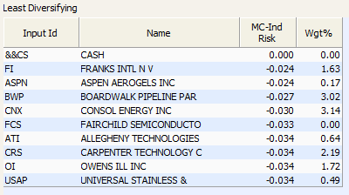

**Question 17**

**Sell: CNX** (Consol Energy Inc.)

The reason we recommend selling CNX is many-fold:

1. It adds the 4th most sector risk (excluding cash), adds the 7th most style risk and the most overall risk
2. Out of the 10 stocks that contribute the most sector risk, it scored the lowest on the US Master Quant Screen with a score of 6.41
3. Several valuation tools show its price will decrease (current price: $10.79)

|  |  |  |
| --- | --- | --- |
| **Valuation** | **Target Price** | **Changes made** |
| Quant | $10.299 (4.55% over-valued) |  |
| Bloomberg DDM | $1.775 (83.55% over-valued) | LT growth rate of 20.6% |
| eVal | $0 (100% over-valued) | EPS & sales growth match |
| FactSet DCF | $0 (100% over-valued) | Sales growth match & WACC |
| Bloomberg DCF (PG) | $0 - $11.12 | Set WACC to 8% |
| Bloomberg DCF (EBITDA M) | $0 – $5.44 | Set exit EBITDA to 4.72x |

1. Selling CNX would reduce the fund’s slight over-exposure to the energy sector versus the mid-cap benchmark
2. Negative earnings surprise of -1427.4% on average over the past 3 quarters
3. But, there has been a lot of insider buying and all types of funds (except Index and Growth) have been buying as well

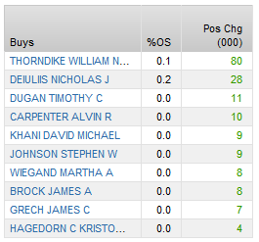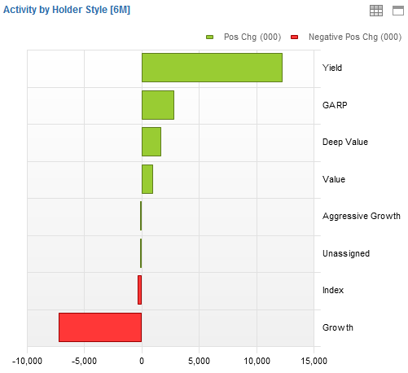

**Buy: ORI** (Old Republic International Corporation)

The reasons we recommend to buy this stock:

1. There has been significant insider buying lately

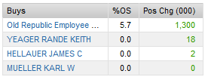

1. It is a midcap financial stock (market cap of $4.8B), which could allow the fund to repair some of its heavy underweighting in this sector compared to the benchmark
2. It got the 7th highest score on the US Master screen for midcap stocks, with a score of 3.78)
3. Several valuations return an upside potential (current price: $18.44)

|  |  |  |
| --- | --- | --- |
| **Valuation** | **Target Price** | **Changes made** |
| Quant | $20.03 (8.6% upside) |  |
| Bloomberg DDM | $18.804 (1.97% upside) | LT growth rate of 5% |
| eVal | $18.53 (0.4% upside) | EPS & sales growth match |
| FactSet DCF | NA | Sales growth match & WACC |
| Bloomberg DCF (PG) | $25.84-$59.69 | Set WACC to 8% |
| Bloomberg DCF (EBITDA M) | $11.33-$26.12 | Set exit EBITDA to 5.8x |

1. Positive earnings surprise of 28.625% on average over the last 4 quarters
2. 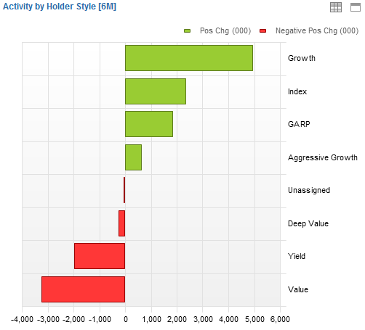But, value funds have been selling the stock

**Question 18**

**Sell: SQBG** (Sequential Brnds. Group)

The rationale behind our sell recommendation on SQBG is the following:

1. It adds the 6th most style risk to the fund
2. Out of the 10 stocks that contributed most style risk, it scored the worst (by far) on the Kai Lucky 11 Quant Screen, with a score of 8.1
3. Multiple valuations indicate a potential price drop (current price: $6.65)

|  |  |  |
| --- | --- | --- |
| **Valuation** | **Target Price** | **Changes made** |
| Quant | $5.79 (13% over-valued) |  |
| Bloomberg DDM | $5.695 (14.36% over-valued) | LT growth rate of 15% |
| eVal | $0 (100% over-valued) | EPS & sales growth match |
| FactSet DCF | $0 (100% over-valued) | Sales growth match & WACC |
| Bloomberg DCF (PG) | $205 - $ 1049.36 | Set WACC to 8% |
| Bloomberg DCF (EBITDA M) | $0 - $16.47 | Set exit EBITDA to -5.4x |

1. But, there has been significant insider and institutional buying lately and the selling the stock would intensify the fund’s under-exposure in consumer discretionary

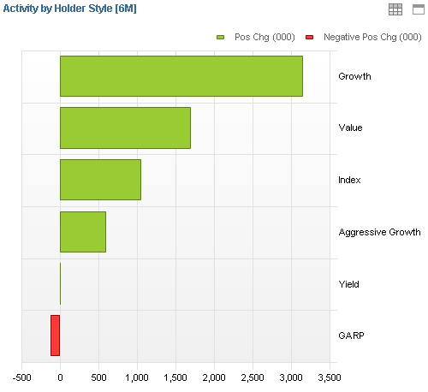

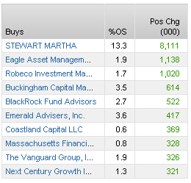

**Buy: CIM** (Chimera Investment Corporation)

The reasons we recommend to buy this stock are as follows:

1. It is a mid-cap financial stock, which would resolve some of the fund’s under-exposure in that sector versus the benchmark.
2. It got the highest score on the Kai Lucky 11 Quant Screen, with a score of 2.2.
3. Insiders have recently been buying significantly:

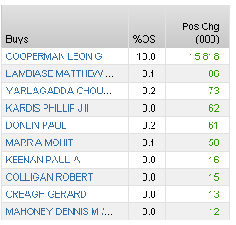

1. Several valuation methods result in a large potential upside (current price: $13.54)

|  |  |  |
| --- | --- | --- |
| **Valuation** | **Target Price** | **Changes made** |
| Quant | $15.77 (16.5% upside) |  |
| Bloomberg DDM | $35.42 (161.59% upside) | LT growth rate of 5% |
| eVal | $25.10 (85.37% upside) | EPS & sales growth match |
| FactSet DCF | $0 (100% over-valued) | Sales growth match & WACC |
| Bloomberg DCF (PG) | $0 (100% over-valued) | Set WACC to 8% |
| Bloomberg DCF (EBITDA M) | $0 - $1.83 | Set exit EBITDA to 29.4x |

1. But, value funds have recently been seen selling CIM  
   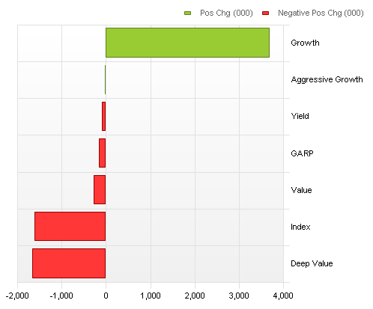

**Question 19**

**Sell: HON** (Honeywell International Inc.)

The reasons we think this stock is misplaced in this fund are:

1. The stock is the only position that the Delafield fund holds in mega-cap stocks (HON has a market cap of $86B), and since the fund is a midcap fund, it shouldn’t be invested in mega-cap stocks. Additionally, only 0.76% of institutional holders that hold HON are mid-cap funds.

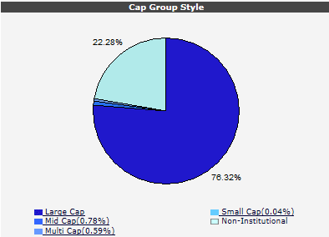

1. HON is an industrial stock and the fund is heavily over-exposed in industrials (with over 35% of its holdings in industrials verses about 18% of the benchmark). Eliminating these holdings would at least somewhat reduce the over-exposure.
2. The Delafield fund considers itself to be a value fund. However, HON isn’t necessarily a value stock, with a relatively low div. yield (2.1%) and a higher-than-market PE ratio (17.15 vs. 7.92). This can be seen by the fact that the stock is mainly owned by Growth, index and yield funds.

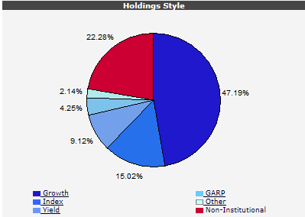

1. 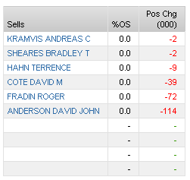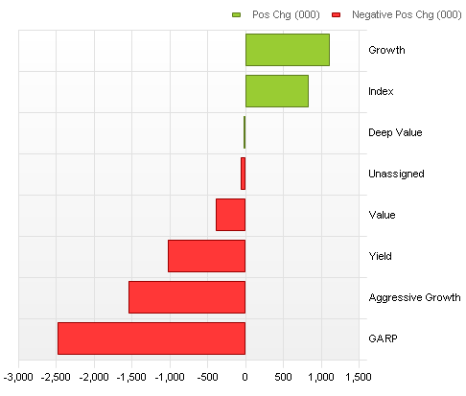Value funds have recently been selling the stock. The same is true for insiders:
2. However, all but 5 analysts covering the stock have buy/outperform recommendation.

**Buy: EXPR** (Express, Inc.)

Our rationale for buying this stock is many-fold:

1. It is a small-cap consumer discretionary stock, so it fits nicely into Delafield’s portfolio, which has 26.25% invested in small-cap equity. Additionally, it would correct some of the fund’s under-exposure in the consumer discretionary sector.
2. As consumer discretionary stocks are generally lower risk, the addition of EXPR might be able to reduce some of the over-exposure to the volatility style that the fund currently has relative to the benchmark.
3. The stock was the best performing consumer discretionary stock in the US Master screen and the second best stock overall, with a score of 3.27
4. 6/18 analysts covering the stock rate is as out-perform whereas another 9 rank it as buy/hold
5. Several valuations suggest a potential upside (current price: $21.39)

|  |  |  |
| --- | --- | --- |
| **Valuation** | **Target Price** | **Changes made** |
| Quant | $23.77 (11.15% upside) |  |
| Bloomberg DDM | $22.343 ($4.457% upside) | LT growth rate of 12% |
| eVal | $41.01 (91.87% upside) | EPS & sales growth match |
| FactSet DCF | $19.8 - $28.00 | Sales growth match & WACC |
| Bloomberg DCF (PG) | $27.74 - $63.51 | Set WACC to 8% |
| Bloomberg DCF (EBITDA M) | $30.44 - $55.11 | Set exit EBITDA to 9.8x |

1. Positive earnings surprise of 30.825% on average over the past 4 quarters
2. But, both value investors as well as insiders have been selling lately:

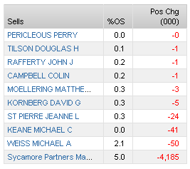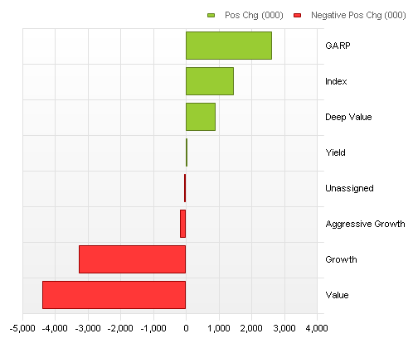

**Question 20**

No, the fund manager does not hold HON in their other funds (Tocqueville Select Fund). In fact, that fund has no investment sin mega-cap stocks whatsoever.

**Question 21**

Information ratio = -1.28, which is mainly due to the more-than 8% under-performance relative to the benchmark. This ratio is pretty bad, since it basically indicates to investors that for each additional unit of active risk they take on, the actually get less return.

**Question 22**

I would not provide a salary increase for the manager of the Delafield fund, for the following reasons:

1. The fund has underperformed the market over the last 5 years by 7.23%, or about 7.44% beta-adjusted, and has had a large negative return over the past year.
2. The fund claims to be a US equity fund, but only 82.59% of the fund’s assets are invested in the North American market (with at least 4.85% invested in emerging markets, which adds additional risk).
3. The fund claims to be an equity fund, but only about 91% of assets are invested in equity securities, with the remaining 10% invested in fixed-income products. This heavily dilutes the fund’s risk profile and makes the fund’s high active risk even worse. Interestingly, the fund itself claims that it reserves the right to invest up to 40% of it AUM in non-equity instruments, which seems extraordinarily high for a mutual funds.
4. The fund claims to be a mid-cap fund, but has over 7% of its assets invested in either mega-or microcap equity.
5. The fund has a 10% stake in cash, which seems unreasonably high for any type of mutual fund.